
BOURNE GRAMMAR SCHOOL BULLETIN

Friday 26 September 2025
From Mark Brunker, Headteacher

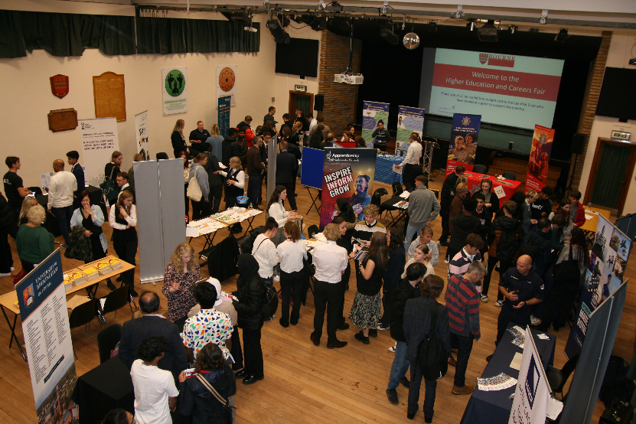
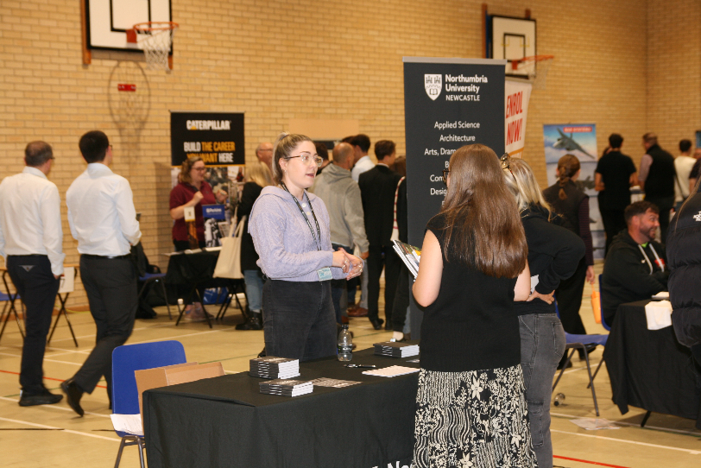
That same spirit of curiosity will be just as valuable at our upcoming Careers Fair next Wednesday evening, a fantastic opportunity for students and parents to explore future pathways, discover possibilities, and ask questions of the many universities, colleges and employers who will be joining us. Further details are included later in this Bulletin, and I would strongly encourage all students in Years 10–13, along with their parents, to attend.

Finally, it was brought to our attention that a system glitch had meant some parents have not been receiving the weekly Bulletin. We apologise for any inconvenience caused and we believe this has now been resolved, but also just a reminder that the Bulletin is also available on the School website.
Employers and HE Providers manning the stands
Careers Fair in full flow
With our School Council in full swing this week and meetings taking place across all year groups, I am looking forward to sitting down with the Head Students to hear the latest feedback and ideas. Having such a comprehensive Council system running right through the school is invaluable, as it gives every student a genuine opportunity to share their views and help shape school life. I am very grateful to all those who give their time, thought and energy to making it so effective.

The Leadership Team had the real privilege of completing Learning Walks this week – short lesson drop-ins across a wide range of subjects and year groups. What we saw was genuinely uplifting: lessons full of energy and interaction, students challenged to think hard, and teachers drawing out understanding with great skill. On more than one occasion I was enjoying the lesson so much that I nearly forgot my ten minutes were up. It really was a joy to see such expertise in action, and a reminder of how fortunate our students are to experience teaching of this calibre every day.

And speaking of brilliance, a slightly unusual example came on the school field recently. A GPS line-marking robot had been programmed to paint out the white rugby and football lines. The timing wasn’t ideal. It was the middle of lunch, with the field full of students. I half-expected chaos, or maybe the robot calmly painting its way across a student’s blazer (Students reading this: that’s not intended as inspiration for next time…). But no, not at BGS. The robot carried on, utterly undisturbed. Instead of interfering, the excitement turned into fascination, with groups of students gathering around to discuss the technology behind it. It felt like their own impromptu lesson, sparked by curiosity about the software and sustained by the kind of thoughtful questioning seen in classrooms all week. Clearly, they’ve been learning from the very best.

Message from Headteacher
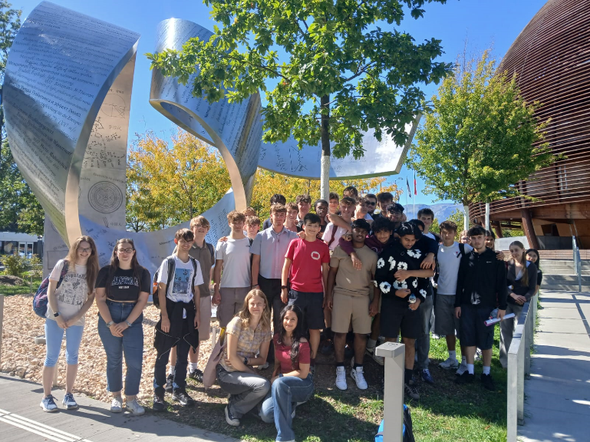
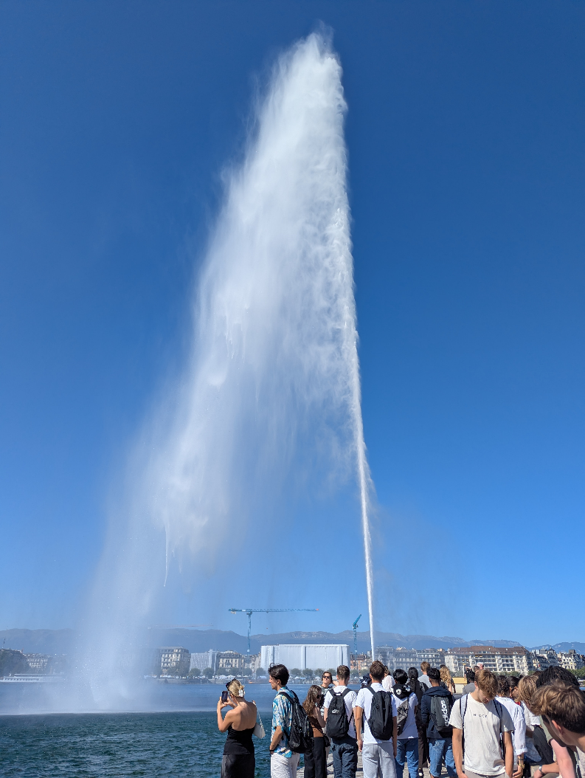
Year 13 CERN Trip

“On Thursday, we did the “Physics” segment of the trip. We visited the Swiss Plasma research centre, where we learned about nuclear fusion and discovered that Swiss plasma does not have holes in it, and the CERN Science Gateway, where we were amazed by the hands-on exhibits.

After this, we took a cable car to the top of Mont Salève (which is actually in France), where we enjoyed the gorgeous views over the city and Lake Geneva spread out below us.

The Most Important Part, however, was the evening meal of both cheese and beef fondue with a side of unlimited chips (and we ate loads!)

Great atmosphere, great physics, great trip!”

- Mayra Narang and Olivia Dunicz

“As a group, I think one of our favourite parts of the trip was the day we spent in Bern. We were able to experience the city through a fabulous, guided tour before visiting Einstein's house and the Bern Historical Museum. There was always something for everyone to do and we also enjoyed having our own time to explore the beautiful city of Bern.”

- Erin French

Geneva Fountain

Group photo at CERN
On Wednesday we were up bright and early ready for our train ride to Bern. During the journey we enjoyed the picturesque views of Lake Geneva and the surrounding countryside visible from the train, and eventually arrived at the capital. From there we began our guided tour of the city, stopping at the iconic Zytglogge clock tower and Swiss Parliament before we were treated to views of the Aare, the iconic emerald river which traverses the city. This was followed by a visit to Einstein’s house within which he first began developing his theory of special relativity leading to the famous equation E = mc2. The day was rounded off with dinner in a restaurant overlooking the river, but not before we had the chance to spot the several bears which call the city home in their riverbank enclosure.
- Thomas Wright-Lakin

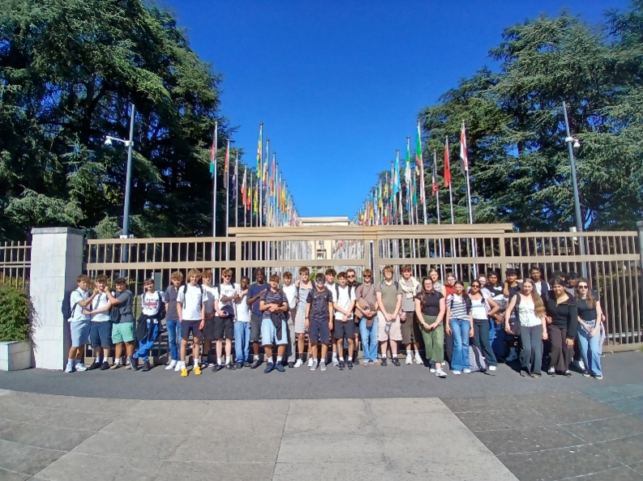

Group photo at the UN headquarters

Music – Mr M Jones

House Totals
 |  |  | 
10005 | 8730 | 9915 | 9330

These totals show all House Points earned minus Behaviour Points.
It includes points from all students in each house for Term 1 up to 25/09/2025.

Students of the Week

Name | Year | Type | Staff | Subject
Emilia Bates | 7 | Learner of the Week | Miss Speakman | English
Jessica Bedford | 7 | Person of the Week | Mrs McAuley | Pastoral
Tim Candy | 7 | Learner of the Week | Mr Bainbridge | History
Miles Cranston | 7 | Learner of the Week | Mr Bainbridge | History
Thomas Smith | 7 | Learner of the Week | Mrs Welling | Art
Aeon Turner | 7 | Learner of the Week | Mr Delport | Design Engineering
Matthew Bullen | 7 | Learner of the Week | Ms Jacometti | Art
Patrick Hines | 7 | Learner of the Week | Miss Davis-Williams | EPR
Nancy Jones | 7 | Learner of the Week | Mrs Allen | English
Nancy Jones | 7 | Person of the Week | Mrs Greenfield | Pastoral
Austin Pitman | 7 | Learner of the Week | Miss Hodge | History
Edie Smith | 7 | Person of the Week | Mrs Cowell | Pastoral
Romeo Angel | 8 | Learner of the Week | Mrs Evans | Geography
Basem Awadallah | 8 | Learner of the Week | Mrs Charters | Spanish
Charly Berry | 8 | Learner of the Week | Mr Bainbridge | History
Harper Bridges | 8 | Learner of the Week | Mr Williamson-Ward | English
Amalie Keegan | 8 | Learner of the Week | Miss Davis-Williams | EPR
Krisha Koirala | 8 | Learner of the Week | Mrs Charters | Spanish
Hamish Shorrock | 8 | Learner of the Week | Miss Davis-Williams | EPR
Andrés Valdez | 8 | Person of the Week | Mrs Peiro Hernandez | Pastoral
Odeta Cukanova | 8 | Person of the Week | Mrs Pickup | Pastoral
Grace Pearce-Higginson | 8 | Person of the Week | Ms Ordonez | Pastoral
Ananya Sahoo | 8 | Learner of the Week | Mr Calver | Mathematics
Toby Scholes | 8 | Person of the Week | Miss Roberts | Pastoral
Ronan Summers | 8 | Learner of the Week | Miss Hodge | History
Prashitha Yelkoti | 8 | Learner of the Week | Mr Moore | Art
Jorgie Binns | 9 | Learner of the Week | Mrs Williamson | English
Anna Da Silva | 9 | Person of the Week | Mrs Pryor | Pastoral
Zach Beeken | 9 | Person of the Week | Dr Hanson | Pastoral
Zach Beeken | 9 | Person of the Week | Dr Hanson | Pastoral
Lavinia Bomford | 9 | Learner of the Week | Miss Roberts | Pastoral
Rishita Dutta | 9 | Learner of the Week | Mrs Greenfield | Geography
Finn Huddart | 9 | Learner of the Week | Miss Dye | English
Yusuf Kebbeh | 9 | Person of the Week | Mr Brooker | Pastoral
Name | Year | Type | Staff | Subject
Abigail Lakin | 9 | Learner of the Week | Dr Barmby | History
Finn Lemon | 9 | Learner of the Week | Dr Barmby | History
Imaan Manji | 9 | Person of the Week | Mr Farrow | Pastoral
George Neave | 9 | Learner of the Week | Miss Patman | Spanish
Oakley Saville | 9 | Learner of the Week | Miss Patman | Spanish
Carys Collingridge | 10 | Learner of the Week | Ms Jasinska | Spanish
Freddie Neal | 10 | Learner of the Week | Miss Hodge | History
Kasper Pryke | 10 | Person of the Week | Miss Hodge | Pastoral
Toby Bell | 10 | Person of the Week | Mr Bowers | Pastoral
Louis McGruer | 10 | Learner of the Week | Ms Bennett | English
Izzy Palmer | 10 | Person of the Week | Ms Jones | Pastoral
Charlie Bedford | 11 | Learner of the Week | Miss Dorosenko | Biology
Luca Christoudias | 11 | Person of the Week | Mr Ray | Pastoral
Charlie Doud | 11 | Learner of the Week | Ms Atkinson | EPR
Aryan Makwana | 11 | Learner of the Week | Mr Miller | Physics
Peter Skinner | 11 | Learner of the Week | Mrs Williamson | English
Kiki Timmins | 11 | Person of the Week | Mrs McAuley | Pastoral
Diyaan Trivedi | 11 | Learner of the Week | Miss Dorosenko | Biology
Luca Christoudias | 11 | Person of the Week | Dr Pritchard-Murphy | Pastoral
Beau Clifford | 11 | Learner of the Week | Mr Lennox | Physics
Alex Homza | 11 | Person of the Week | Ms Kemp | Pastoral
Danesha Kumari | 11 | Learner of the Week | Mr Williamson-Ward | English
Aryan Makwana | 11 | Learner of the Week | Mr Perez | Biology
Aleena Malik | 11 | Learner of the Week | Dr Pritchard-Murphy | Mathematics
Charlotte Mason | 11 | Learner of the Week | Ms Bennett | English
Zara Ormanova | 11 | Learner of the Week | Mrs Pickup | Drama
Adeena Sajid | 11 | Learner of the Week | Mr Farrow | Statistics & Further Mathematics
Matilda Shreeve | 11 | Person of the Week | Mr Lennox | Pastoral
Dexter Vipond | 11 | Learner of the Week | Mr Perez | Biology
Oliver Webb | 11 | Learner of the Week | Ms Jones | English
Elisa Wright | 11 | Learner of the Week | Mr Calver | Mathematics
Zeke Young | 11 | Person of the Week | Mr Lennox | Pastoral
Emma Hodson | 12 | Person of the Week | Mr Tighe | Pastoral
Alice Jones | 12 | Learner of the Week | Ms Bowtell | Sports Studies
Oliver Walker | 12 | Learner of the Week | Ms Kemp | English Literature
Martha Yates | 12 | Person of the Week | Mrs Holbrook | Pastoral
Ewan Dragota | 12 | Learner of the Week | Mr Hartley | Economics
Balinda Iyiegbu | 12 | Learner of the Week | Mr Williamson-Ward | English Language
Maisie Jeffs | 12 | Learner of the Week | Mr Williamson | Media Studies
Samyutha Puppala | 12 | Person of the Week | Dr Hobbiss | Pastoral
Bronte Wyvill | 12 | Learner of the Week | Mrs Bolitho | English Literature
Gabriella Clarke | 13 | Learner of the Week | Ms Kemp | English Language
Matilda Isitt | 13 | Learner of the Week | Miss Pollard | Geography
Maihvan Kalaiselvan | 13 | Learner of the Week | Mrs Lattimer | Mathematics
Masha Morozova | 13 | Learner of the Week | Dr Hanson | Biology
Lillie Hipwell | 13 | Person of the Week | Mr Hartley | Pastoral
Isabelle Riley | 13 | Person of the Week | Mr Jones | Pastoral
Ayesha Shazad | 13 | Learner of the Week | Mr Jones | Business Studies

Progress Review Meetings
Progress Review Meetings (PRMs) offer an opportunity for a one-to-one discussion with your child’s teachers to explore their progress in more detail and ask any questions you might have.

PRM appointments take place online, using either a smartphone or computer. Information and guidance about PRM, including your login details and how to book appointments online will be sent nearer the date by email to Priority 1 parents (as recorded on our database).

Students will be set work to complete at home on the PRM day in June (per subject lesson timetabled on that day) and are strongly encouraged to attend their meeting virtually along with parent(s)/carer(s).

Year 13 Progress Review Evening - Thursday 6 November 2025 (17:00-20:30)
Year 11 Progress Review Evening - Thursday 15 January 2026 (17:00-20:30)
Year 12 Progress Review Evening - Thursday 14 May 2026 (17:00-20:30)
PRM day for KS3 (Years 7, 8 & 9) and Year 10 on Friday 26 June 2026 (08:30-18:30),
PRM evenings for KS3 (Years 7, 8 & 9) and Year 10 on:
Thursday 2 July 2026 (17:00-20:30), and
Wednesday 8 July 2026 evenings (17:00-20:30).

Year 9 Options Evening – Thursday 26 February 2026
Year 9 students, in discussion with their parents, will be asked to choose the GCSE subjects they would like to study in Years 10 and 11. The Options Evening is an opportunity for Year 9 students and their parents to find out more about the Key Stage 4 (GCSE) curriculum, and to speak with subjects teachers to learn more about the choices available.

Bourne Grammar School Careers and Higher Education Fair

The Bourne Grammar School biennial Careers Fair will be taking place on Wednesday 1 October 6pm-8.30pm.

All students and parents in years 10-13 are invited to attend.

It promises to be a fabulous evening with more than 60 universities, colleges and employers attending. Just a few of those confirmed are below.
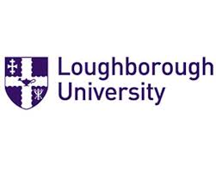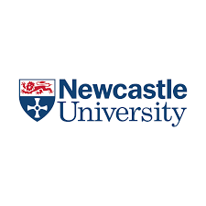

Weekly Winners’ Competition
Another excellent week in Year 9, as students continue to impress with their dedication, resilience, and effort. We are proud to recognise the efforts of Week 3’s winners, who gained the most House Points in their group over Week 3 of term. Some students you may recognise as winners from Week 1 and 2 – a fantastic achievement to be listed here again, and showing their continued commitment. A huge congratulations to all the students listed – keep up the fantastic work.

Congratulations to all our Weekly Winners!

Group | Week | Top Student | Points Gained
1 | 3 | Rishita Dutta | 18
2 | 3 | Aarikha Arunkumar | 17
3 | 3 | Jace Gwiti | 20
4 | 3 | Alessia Pacitti | 30
5 | 3 | Amberley Keith | 23
6 | 3 | Viganth RG | 28
7 | 3 | Jorgie Binns | 31
8 | 3 | Sofia Christoudias | 31
9 | 3 | Roisin Baker | 19
10 | 3 | Alisha Chakamanga | 17
11 | 3 | Anna Da Silva | 31
12 | 3 | Freddie Gibson, Joey Dickins | 18
13 | 3 | Lavinia Bomford | 27
14 | 3 | Caoimhe Healy | 17
15 | 3 | Suraj Yadravi | 17
16 | 3 | Isabelle Bradley, Rilan Haria | 15
17 | 3 | Dylan Kennard | 14
18 | 3 | Sienna Thomas | 18
19 | 3 | Wonu Oluwasanmi | 16
20 | 3 | Kamsi Anike | 21
21 | 3 | Ted Moocarme | 25
22 | 3 | Daniel France | 28

Pokémon Club
Mrs R Evans, Head of Year 8

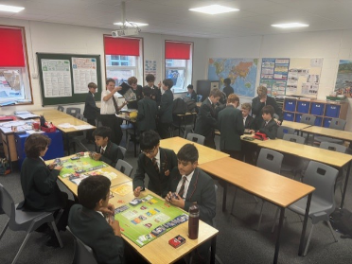
On Friday lunchtimes a new student-led Pokémon Club is running in Geography 4.

This week was the first gathering and there was lots of excitement and enthusiasm as students played games and shared their cards.

Enthusiasts from Years 7,8 & 9 were present and the atmosphere was lovely.

Well done to Jonathan in Year 8 who is leading the club.

We hope to see more students joining in next week.

Pokémon Club off to a great start

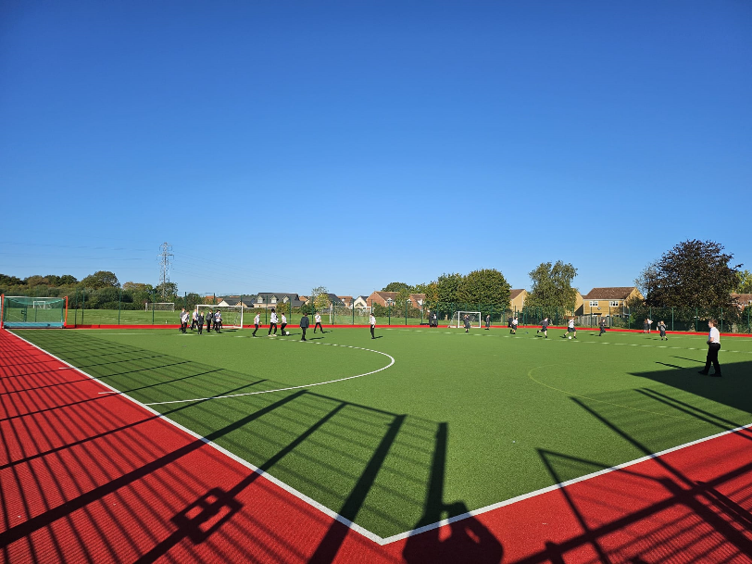
Achievement Points Competition
Mrs R Evans, Head of Year, and Mr A Graves, Deputy Head of Year

Congratulations to 8F who were the winners of our Achievement Points competition last week. Very worthy winners, with a very impressive total of achievements points!

8F were rewarded with a lovely sunny kick-about on the Astro during Monday’s form time; a treat thoroughly enjoyed by all.

Duke of Edinburgh Awards

Congratulations to the following students who have been awarded their Bronze or Silver DofE Certificates this week:

Year 11 – Bronze Success

Henry Hodson
Abolaji Oluwasanmi
Kayla Reihill
Michael Sarfo

Year 12 – Silver Success

Merryn Baldock
Alice Barratt
Evan Bates
Jacob Didsbury
Miles Garrido
Oliver Hill
James Houghton
Oscar Huang
Shiksha Kaur
Charles Kavati
Paula Kriauciunaite
Hannah Lessiter
Hamsini Rajaalagappan
Jesire Richardson
Emily Seaton
Filip Wiza

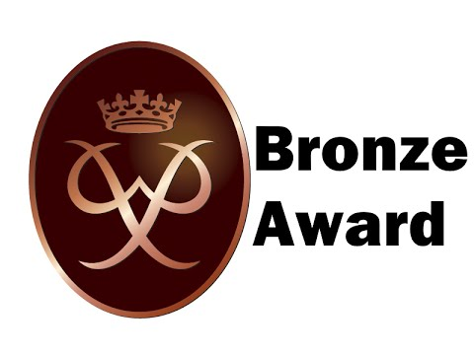



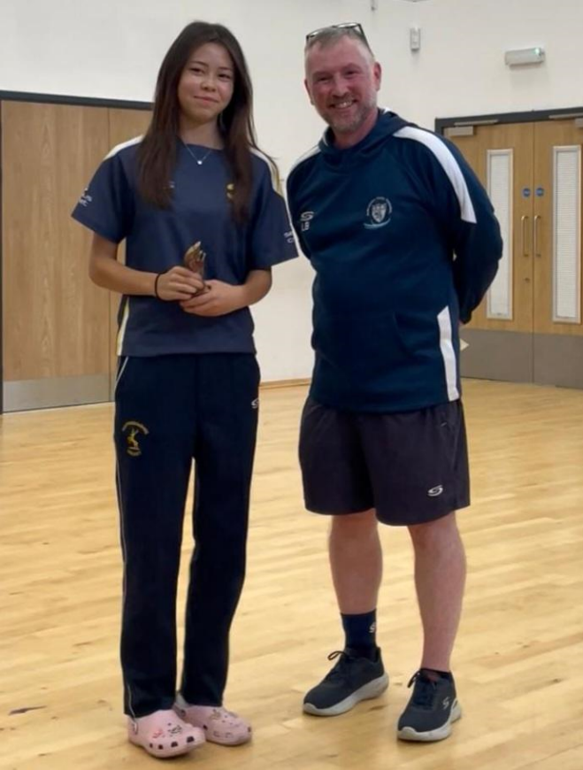
Introducing New Student Council Representatives 2025-2026
We are excited to announce that this year’s Student Council representatives have been selected and are ready to step into their leadership roles. These students will work closely with their peers and School staff to ensure that student voice is heard and valued over the next academic year.
The Student Council is a crucial platform in School that encourages student engagement and leadership development. Each tutor group from Years 7 – 12 has a designated Student Council Representative and all meetings are minuted by the Year 13 Senior Prefects and Head Students who take on the role of Chair.
Through the Council, students learn essential skills like teamwork, communication, and problem-solving. Most importantly, they become advocates, representing their fellow students’ needs and ideas in everything, from School events and activities, to policies and initiatives that affect the entire School community.
For students, this is your chance to share your thoughts and ideas. Whether it's improving School facilities, creating new clubs, or addressing issues that matter to you, your new representatives are here to listen and act on your behalf. The success of our Student Council relies on participation from everyone—so don't hesitate to reach out to your new reps and get involved.
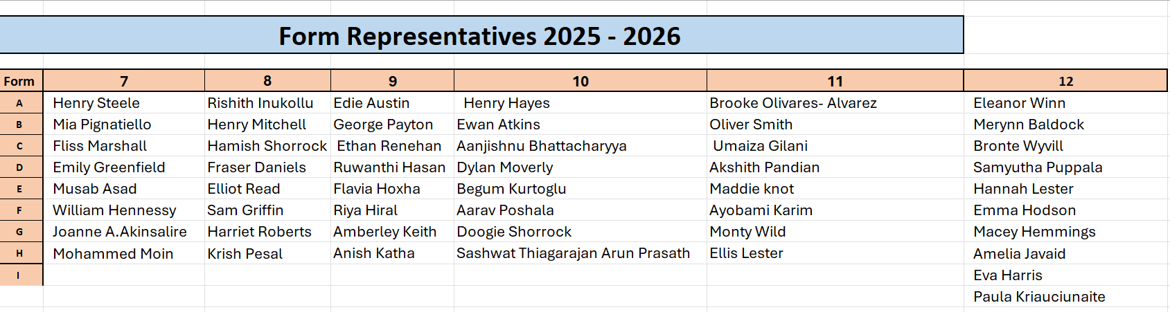
Individual Success

Lois Cox (Year 11) was presented with the County U15 Girls Bowling Award for 2025 by her coaches at Cricket East (Huntingdonshire and Bedfordshire) in a ceremony on 21 September.

In the same weekend, Lois, who bowls leg-spin, was also given the 2025 U15 (Combined Boys and Girls) Bowling Award by her club team, Nassington.

Her personal best figures of 6 wickets for 2 runs came in a U15 Hunts Youth League match in June.

Congratulations, Lois!

